**-- 1.1 Select the names of all the products in the store.**

**-- 1.2 Select the names and the prices of all the products in the store.**

**-- 1.3 Select the name of the products with a price less than or equal to $200.**

**-- 1.4 Select all the products with a price between $60 and $120.**

**-- 1.5 Select the name and price in cents (i.e., the price must be multiplied by 100).**

**-- 1.6 Compute the average price of all the products.**

**-- 1.7 Compute the average price of all products with manufacturer code equal to 2.**

**-- 1.8 Compute the number of products with a price larger than or equal to $180.**

**-- 1.9 Select the name and price of all products with a price larger than or equal to $180, and sort first by price (in descending order), and then by name (in ascending order).**

**-- 1.10 Select all the data from the products, including all the data for each product's manufacturer.**

**-- 1.11 Select the product name, price, and manufacturer name of all the products.**

**-- 1.12 Select the average price of each manufacturer's products, showing only the manufacturer's code.**

**-- 1.13 Select the average price of each manufacturer's products, showing the manufacturer's name.**

**-- 1.14 Select the names of manufacturer whose products have an average price larger than or equal to $150.**

**-- 1.15 Select the name and price of the cheapest product.**

**-- 1.16 Select the name of each manufacturer along with the name and price of its most expensive product.**

**-- 1.17 Add a new product: Loudspeakers, $70, manufacturer 2.**

**-- 1.18 Update the name of product 8 to "Laser Printer".**

**-- 1.19 Apply a 10% discount to all products.**

**-- 1.20 Apply a 10% discount to all products with a price larger than or equal to $120.**

CREATE TABLE Manufacturers (

Code INTEGER,

Name VARCHAR(255) NOT NULL,

PRIMARY KEY (Code)

);

CREATE TABLE Products (

Code INTEGER,

Name VARCHAR(255) NOT NULL ,

Price DECIMAL NOT NULL ,

Manufacturer INTEGER NOT NULL,

PRIMARY KEY (Code),

FOREIGN KEY (Manufacturer) REFERENCES Manufacturers(Code)

) ENGINE=INNODB;

INSERT INTO Manufacturers(Code,Name) VALUES(1,'Sony');

INSERT INTO Manufacturers(Code,Name) VALUES(2,'Creative Labs');

INSERT INTO Manufacturers(Code,Name) VALUES(3,'Hewlett-Packard');

INSERT INTO Manufacturers(Code,Name) VALUES(4,'Iomega');

INSERT INTO Manufacturers(Code,Name) VALUES(5,'Fujitsu');

INSERT INTO Manufacturers(Code,Name) VALUES(6,'Winchester');

Select * from Manufacturers;

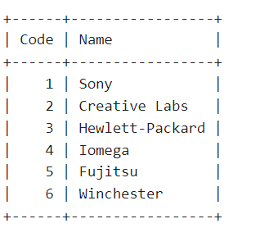

INSERT INTO Products(Code,Name,Price,Manufacturer) VALUES(1,'Hard drive',240,5);

INSERT INTO Products(Code,Name,Price,Manufacturer) VALUES(2,'Memory',120,6);

INSERT INTO Products(Code,Name,Price,Manufacturer) VALUES(3,'ZIP drive',150,4);

INSERT INTO Products(Code,Name,Price,Manufacturer) VALUES(4,'Floppy disk',5,6);

INSERT INTO Products(Code,Name,Price,Manufacturer) VALUES(5,'Monitor',240,1);

INSERT INTO Products(Code,Name,Price,Manufacturer) VALUES(6,'DVD drive',180,2);

INSERT INTO Products(Code,Name,Price,Manufacturer) VALUES(7,'CD drive',90,2);

INSERT INTO Products(Code,Name,Price,Manufacturer) VALUES(8,'Printer',270,3);

INSERT INTO Products(Code,Name,Price,Manufacturer) VALUES(9,'Toner cartridge',66,3);

INSERT INTO Products(Code,Name,Price,Manufacturer) VALUES(10,'DVD burner',180,2);

Select * from Products;

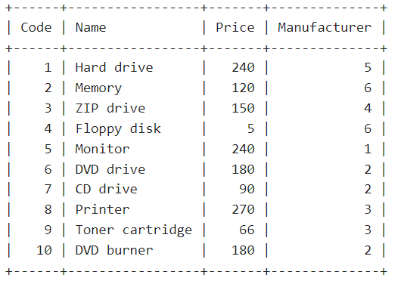

-- 1.1 Select the names of all the products in the store.

select Name from Products;

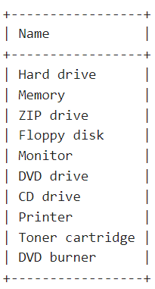

-- 1.2 Select the names and the prices of all the products in the store.

**select name, price from products;**

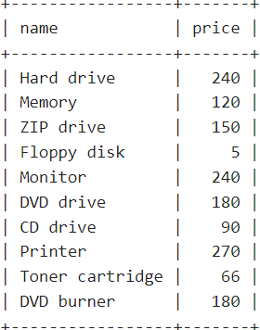

-- 1.3 Select the name of the products with a price less than or equal to $200.

**select name from products where price <= 200;**

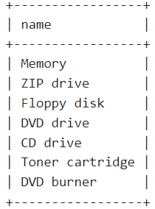

-- 1.4 Select all the products with a price between $60 and $120.

**select * from products where price between 60 and 120;**

**select * from products where price >= 60 and price <= 120;**

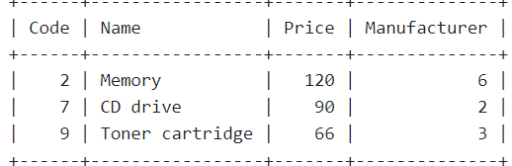

-- 1.5 Select the name and price in cents (i.e., the price must be multiplied by 100).

**select name, price*100 from products;**

**select name, concat(price*100, ' cents') from products;**

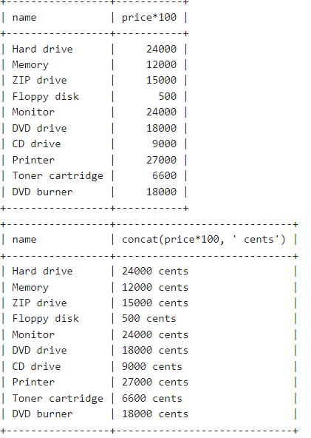

-- 1.6 Compute the average price of all the products.

**select avg(price) from products;**

**select sum(price)/count(price) from products;**

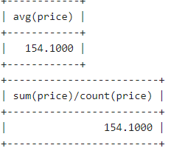

-- 1.7 Compute the average price of all products with manufacturer code equal to 2.

**select avg(price) from products where Manufacturer = 2;**

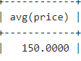

-- 1.8 Compute the number of products with a price larger than or equal to $180.

**select count(*) from products where price>=180;**

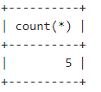

-- 1.9 Select the name and price of all products with a price larger than or equal to $180, and sort first by price (in descending order), and then by name (in ascending order).

**select name, price from products where price>=180 order by price desc, name asc;**

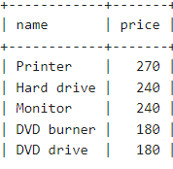

-- 1.10 Select all the data from the products, including all the data for each product's manufacturer.

**select a.*, b.name from products a join Manufacturers b on(a.manufacturer = b.code);**

**select a.*, b.name from products a, Manufacturers b where a.manufacturer = b.code;**

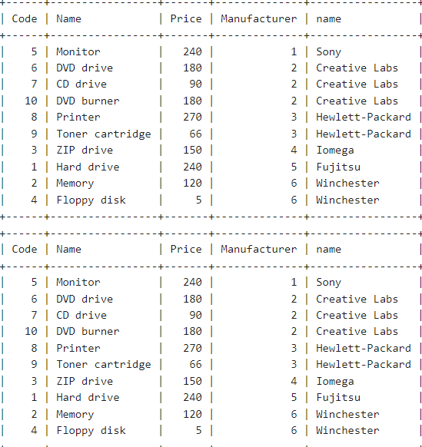

-- 1.11 Select the product name, price, and manufacturer name of all the products.

select a.name, a.price, b.name from products a join Manufacturers b on(a.manufacturer = b.code);

**SELECT Products.Name, Price, Manufacturers.Name**

**FROM Products INNER JOIN Manufacturers**

**ON Products.Manufacturer = Manufacturers.Code;**

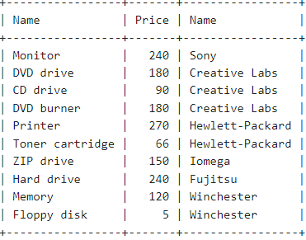

-- 1.12 Select the average price of each manufacturer's products, showing only the manufacturer's code.

**SELECT AVG(Price), Manufacturer**

**FROM Products**

**GROUP BY Manufacturer;**

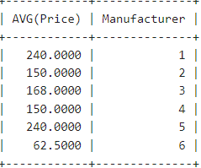

-- 1.13 Select the average price of each manufacturer's products, showing the manufacturer's name.

**select avg(a.price), b.name**

**from Products a join Manufacturers b**

**on a.manufacturer = b.code**

**group by b.name;**

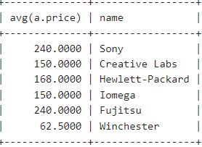

-- 1.14 Select the names of manufacturer whose products have an average price larger than or equal to $150.

**select avg(a.price), b.name**

**from Manufacturers b join Products a on b.code = a.Manufacturer**

**group by b.name**

**having avg(a.price)>=150;**

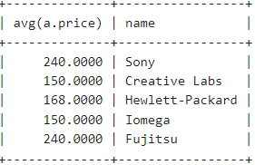

**SELECT AVG(Price), Manufacturers.Name**

**FROM Products, Manufacturers**

**WHERE Products.Manufacturer = Manufacturers.Code**

**GROUP BY Manufacturers.Name**

**HAVING AVG(Price) >= 150;**

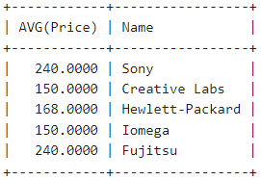

-- 1.15 Select the name and price of the cheapest product.

select name, price from Products

where price = (

select min(price)

from products);

**SELECT name,price**

**FROM Products**

**ORDER BY price ASC**

**LIMIT 1;**

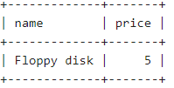

-- 1.16 Select the name of each manufacturer along with the name and price of its most expensive product.

**select max_price_mapping.name as manu_name, max_price_mapping.price, products_with_manu_name.name as product_name**

**from**

**(SELECT Manufacturers.Name, MAX(Price) price**

**FROM Products, Manufacturers**

**WHERE Manufacturer = Manufacturers.Code**

**GROUP BY Manufacturers.Name)**

**as max_price_mapping**

**left join**

**(select products.*, manufacturers.name manu_name**

**from products join manufacturers**

**on (products.manufacturer = manufacturers.code))**

**as products_with_manu_name**

**on**

**(max_price_mapping.name = products_with_manu_name.manu_name**

**and**

**max_price_mapping.price = products_with_manu_name.price);**

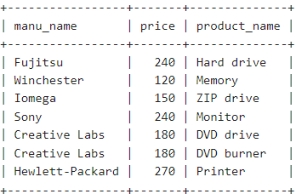

-- 1.17 Add a new product: Loudspeakers, $70, manufacturer 2.

**insert into Products values (11, 'Loudspeakers', 70, 2);**

-- 1.18 Update the name of product 8 to "Laser Printer".

**update products**

**set name = 'Laser Printer'**

**where code=8;**

-- 1.19 Apply a 10% discount to all products.

**update products**

**set price=price*0.9;**

-- 1.20 Apply a 10% discount to all products with a price larger than or equal to $120.

**update products**

**set price = price * 0.9**

**where price >= 120;**